Suggestions for marking Advent at Home

1 Weekly: make your own Advent Ring

Make 4 ‘candles’ out of toilet roll inners by cutting out flames and attaching them to the cardboard. Smaller candles can be made by cutting the inners in half. The central candle for Christmas Day can be the same size, or taller, using either a full-size toilet roll inner or a kitchen roll inner.

On the first Sunday, place the first cardboard candle in a designated place – perhaps on some sort of ring or plate or tray.

OR Make a wreath and candles out of whatever materials you have to hand, with flames that can be raised up – to make the candles light – each Sunday of Advent.

Use a prayer for the 1st Sunday in Advent like this one:
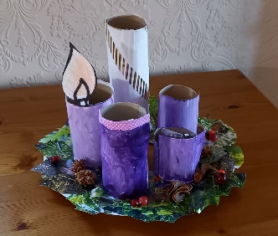

I/we place the first candle for the second coming of Jesus –

the return of Christ in glory at the end of time.

We pray that we will be ready and waiting, today and every day.

Come, Lord Jesus, come.

Then:

I/we place the second candle for the prophets –

those who foretold the coming of the Messiah.

We pray that we too will listen for God’s voice and be prepared to act.

Come, Lord Jesus, come.

I/we place the third candle for John the Baptist –

the man of the desert who prepared the way for the ministry of his cousin.

We pray that our hearts too will be prepared for new insights and encounters.

Come, Lord Jesus, come.

I/we place the fourth candle for Mary –

the girl who listened to God’s word brought by an Angel and who accepted her calling.

We pray that we too will be open to God’s call.

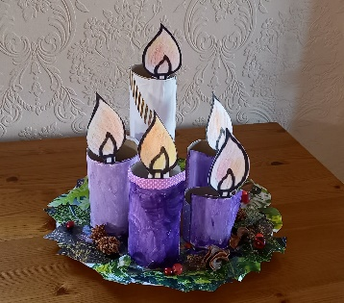
Come, Lord Jesus, come.

I/we place the central candle to celebrate the birthday of Jesus –

‘God with us’ on Christmas Day!

We pray that we will know again the wonder of God’s presence.

Welcome, Lord Jesus.

2 Daily: use an Advent Candle to pray

Use an Advent candle or an ordinary candle (if safe to do so) or make a DIY candle as in the suggestion above. Light it, or place it, each day of Advent and pray a one-sentence prayer for a need in the world.

3 Daily: organise an ‘at home’ Posada

Have some travelling figures of Mary and Joseph move around your house to end up with a crib (or just a baby) on Christmas Day. You may like to use the figures from a nativity set and have the rest of the scene waiting for Mary and Joseph. Or, you may like to make your own. Toilet roll inners will again come in very useful!
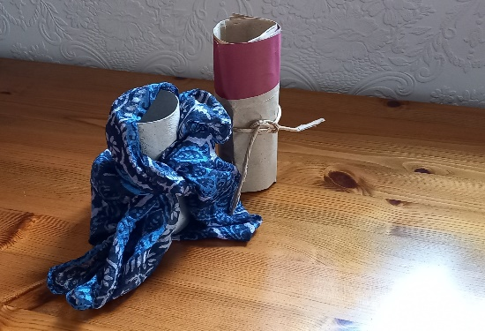

A blue scarf, or piece of cloth, tied round for

Mary; a piece of brown paper and some string

adapted for Joseph; simple representations can easily take on a life of their own.

The journey should start on 1st December at the further point in the house (or bungalow or flat) from where you want them to end up. Then move them a little way each day so that they get nearer and nearer their destination. Say this prayer each day, or another one of your own devising.
Loving God,
We thank you for Mary and Joseph and for their courage and trust.
Thank you for the way their journey from Nazareth to Bethlehem
was paralleled in their journey from being ordinary people
to being the extraordinary people you called them to be.
Please be with us as we travel through Advent this year,
and as we seek to be become the people you call us to be.
May we too have courage and trust. We ask it in the name of Jesus Christ. Amen

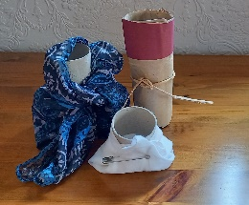
For Christmas Day, create a baby in a similar simple way. a white hanky fastened like a nappy for baby Jesus.

4 Daily: use your existing nativity set to build up the nativity scene

If you have a nativity set with several pieces then place one in position each day to gradually build up the scene. Alternatively, draw the scene or make it up with different objects to represent the different characters. Twenty figures might be:

Mary, Joseph, baby (obviously, these would be left to last), the Stable, the crib, 3 wise men, 3 camels, 2 shepherds, 2 sheep, 1 lamb, 1 donkey, 1 ox, an angel, the star. This would mean starting on December 6th to finish on the 25th. If you only have 10 figures then you would need to start on December 16th and so on.

Jacqui A Horton Advent 2020

